**Space: What do we see in the Night Sky?**

***A. Stars organized into patterns:***

Consider the shape of the sky like an upside-down bowl – the rim of the bowl is the horizon. This model is called the ___________________.

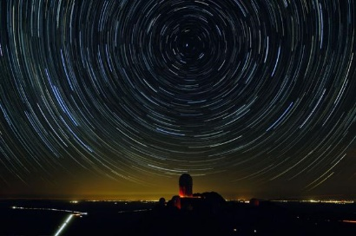

If you watch the stars for a whole night they appear to move from ______________ (as sun does during day). But the stars are not actually moving across the celestial sphere – Earth’s ____________ causes the illusion of movement.

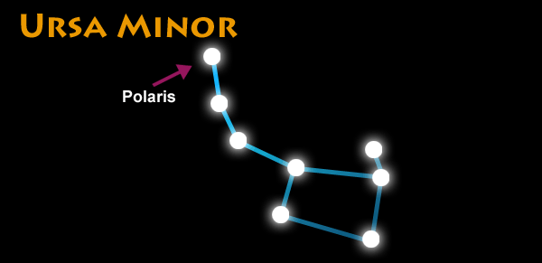The stars appear to rotate __________ a single point in the sky – **the North Star – ____________ -** which seems to stay fixed in place while others move around it.

How to find Polaris?

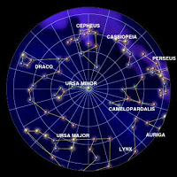We can use **_________________** – patterns formed by other stars

Polaris is the last star in the handle of ______________ (Little Bear), Little Dipper.

Constellations that circle around Polaris are called **_________________** because they travel around the pole star. They are **always** visible in ____________. (Cepheus, Cassiopeia, Camelopardalis, Ursa major (Great Bear), Draco)

***B. We see celestial objects of the universe***

Everything that exists, including celestial objects such as ___________________ as well as all the ___________ and empty ___________ surrounding them is the **Universe**.

**Solar System**

Sun’s gravity exerts a powerful pulling force on the planets. This **________________** is a force of attraction that keeps the planets moving in a ___________ pattern around it. The circular pattern is called an **________**. Planets ____________ around the Sun which means that they move in an orbit around the sun. Most planets also have _________ that orbit around them. The sun, planets, moon, and other objects that orbit the sun make up the **____________________**.

**Stars**

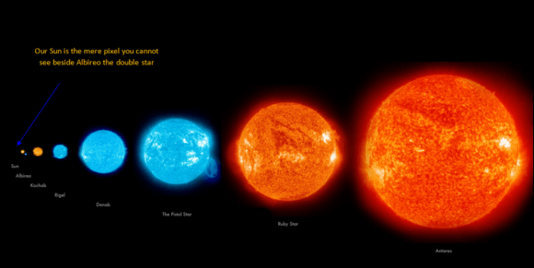A star is a ball-shaped mass of ____________________ that produces and gives off ____________________________________________. Our Sun is a star. Stars vary in ______________________________.

**Galaxies**

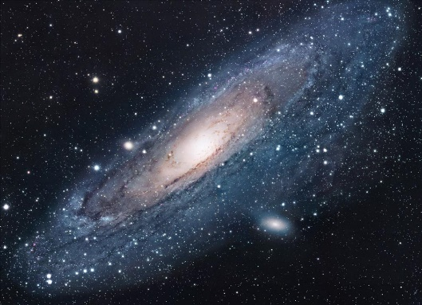A collection of many ___________________ held together by gravity is called a **galaxy**. There are billions and billions of galaxies in the universe. Our solar system is located in the ___________________ galaxy.

Galaxies also contain masses of _____________. The gas is mainly ____________ atoms. Space dust is made up of ______ ___________________. Most of a galaxy is _______ – just empty space!

***C. We see objects separated by immense distances:***

The distances in space are so ___________, using standard distance units does not make sense. Astronomers have created their own units to measure distances in space.

One **astronomical unit (AU)** is equal to ___________________________ ________________________________________________________.

Ex. The distance from the Sun to Neptune is _________

The distance from the Sun to Mercury is ________

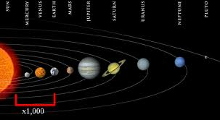

The distance between stars and galaxies is _____________ to be covered in a human lifetime. AUs are not sufficient.

A **light-year** is ____________________________________________.

Light travels at a speed of ____________________

One light year covers _________________ km. Most stars and galaxies are hundreds, thousands and even millions of light-years away!