**Static Electricity!**

**Static Electricity**

* Accumulates on an object to form an electric ________________
* Charges are __________________
* Static Electricity does _________ move through wires.

*Examples:* During thunderstorms – ____________________

When we empty the dryer – ___________________

* When different materials are rubbed together or bump into each other a lot, _____________ leave one surface and collect on the other

*Examples:* - water droplets in a thunderstorm with high winds

- Socks rubbing against a carpet

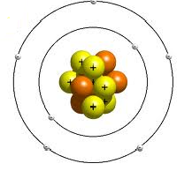**Electron Theory:**

* Matter is made up of ____________
* Recall: 2 types of charges: _______________ and ______________
* Each atom has a positive _______________ made up of _______________ and _______________ that is surrounded by negative _________________
* Neutrons have _________ charge
* The___________ electrons can ___________ around within the substance
* Some materials **gain** electrons and end up with a ___________________ charge
* Some materials **lose** electrons and end up with a ___________________ charge
* When a _________________ object has more electrons than it can hold on to, they are suddenly released, creating a _____________

|  |  |  |
| --- | --- | --- |
| 1. Ebonite rod and Fur | 2. Friction causes the transfer of electrons from the fur to the ebonite rod | 3. The ebonite is charged negatively and the fur is charged positively. |

There are two kinds of materials:

* + 1. **Insulators**
       - If you rub an object, and the charge ___________ on the spot where you rubbed, the material is called an _____________________.
    2. **Conductors**
* If the charges ____________ freely across or through the material, it is called a _________________________.
* Most _________________ are conductors.
* They _________________ hold a static charge.

**The Law of Electric Charges**

* Most objects are __________________ (uncharged) because they have the _________________ number of ***positive*** and ***negative*** charges
* The Law of Electric Charges states that:
  + _____________________________________________________
  + _____________________________________________________
* A _______________ object ________________ both ***positively*** and ***negatively*** charged objects.

N = neutral

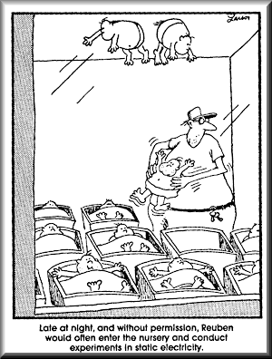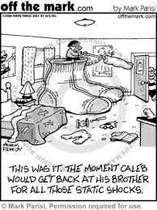

**Homework:**