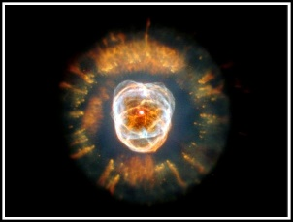

**The Origin of the Universe: The Big Bang Theory**

* “***Time zero***” → _____________________ years ago
* all matter was compacted into a teeny tiny little ______
* little ball was extremely ______, ___________ and under enormous _____________
* small, dense ball _____________ hurling matter and energy in all directions

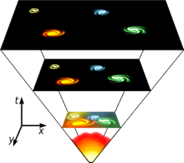***Support:***

* ______________________________________ (the heart or “glow” left over from the explosion)
* __________________

**An Expanding Universe**

* As a balloon expands, so does the universe!
* How do we know??
* Galaxies produce a stream of __________ just as stars do. Yet when we observe different galaxies, the spectrum is not the same as we would expect.
* As the galaxy moves _____, the wavelength of light gets ___________ and shift to the ______ end of the visible spectrum. This is called _______________.

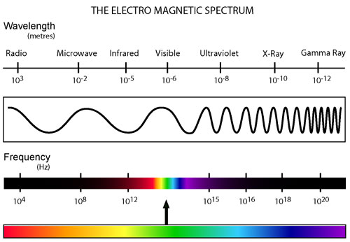

It means that all galaxies are _______________ from us. If fact, the farthest galaxies are moving away the ____________. This means the whole universe is ________________, just like the dots on the balloon

* Supports the _____________ theory of universe formation
* Will it continue to expand? Or will it stop and contract to a _________________??

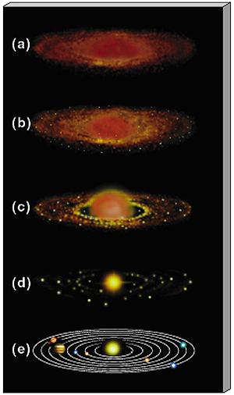

**The Origin of the solar System: The Nebula Theory**

* Formed from a _____________ (an enormous cloud of dust and gas)
* The ______ like all __________ was formed from a nebula
  1. _________ causes the matter of the nebula to _________ and __________
  2. The contracting nebula begins to ___________ into a spinning pancake shape with a bulge at the center. This bulge became the ________.
  3. Some of the cooler material also clumped together because of gravity to form the ______________.