**The Electrostatic Series**

* It is a list of the ___________________ of substances to hold on to their _________________________
* It can be used to determine which substances will get a _____________________ charge and which will get a __________________ charge when rubbed together.
* If electrons are ***lost*** → _________________ charge
* If electrons are ***gained*** → __________________ charge

***Common substances used in electrostatics:***

**Increasing ability to hold electrons**

*when rubbed together, the substance that is closer to the bottom will become **________**, the one closer to the top will become **____________**

**Material**

**acetate**

**glass**

**wool**

**cat's fur, human hair**

**calcium, magnesium, lead**

**silk**

**aluminum, zinc**

**cotton**

**paraffin wax**

**ebonite (vinylite)**

**polyethylene (plastic)**

**carbon, copper, nickel**

**rubber**

**paper**

**sulphur**

**platinum, gold**

Weak hold on electrons

Increasing tendency to gain electrons

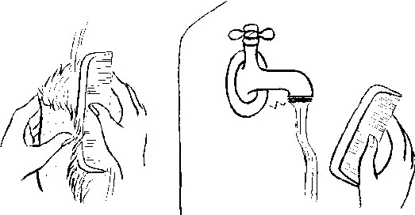

Strong hold on electrons

What would be the result of…

1. Rubbing paper with fur?
2. Rubbing a plastic bag with glass?
3. Rubbing a sheep on a tire?
4. Rubbing a plastic comb with fur?