**Charging an Object**

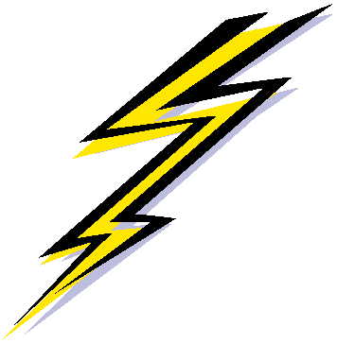

**Recall: Forming an electric charge**

* Object that has an excess of electrons = _____________
* Object has lost loss of electrons = _______________
* Object that has the same # of protons and electrons = _____________

3 ways of transferring electric charges (or electrons):

1. _____________________
2. ______________________
3. ______________________

**1. Charging by Friction:**

* Objects made of ____________ types of matter are rubbed together; this produces a static net _______ on each object because electrons are transferred during the process.
* Recall: ***Electrostatic Series***
  + Matter that has a _________ hold on electrons will _______ electrons and become ___________
  + Matter that has a __________ hold on electrons will _______ electrons and become ______________

**2. Charging by Contact:**

* Charging by contact happens when a ____________ object touches a __________ object.
* Electrons will _______ in attempts to ____________ the charges (spread out) – thus will move ____________ the object has the _______________________________________

**ZAP!**

* + This happens ________ - can be surprising or painful
  + It can even ‘________’ the gap prior to full contact
  + The result is an ________________________!
* The charged object acquires the **_____________________________________**

**__________________________________________**; the total charge is _________________________________.

MC900030327[1]

MC900030327[1]

**3. Charging by Induction:**

* A ___________ object can transfer a charge to a neutral object ***__________________________________***
* Only ______________ can be charged in the induction process
* The ___________ of the charged object forces the _____________ of neutral object to ___________.
* If the charging object is ______________, the electrons _____________.
* If the charging object is ______________, the electrons ______________.
* The result: _______________________________________________________
* 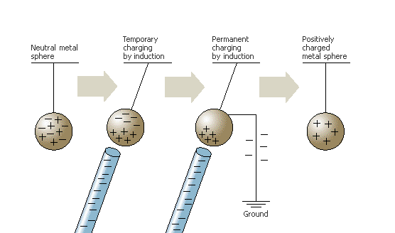If there is a ____________, electrons can move _________ or _______ of the object being charged - the balance is changed and the object is now ___________ - **The induced object obtains an _________________ charge to originally charged object**.