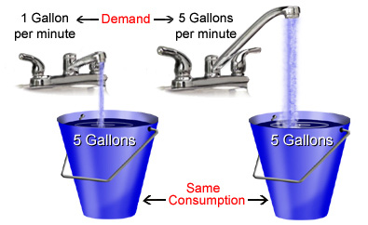**Measuring Current:**

The flow rate of water passing through a hose can be calculated by dividing the amount of water passing a point by the time,

**flow rate = amount of water passing / time**

Electric current is the flow rate of electrons passing through a wire. Current can be calculated by dividing the amount of ______________ by the _____________,

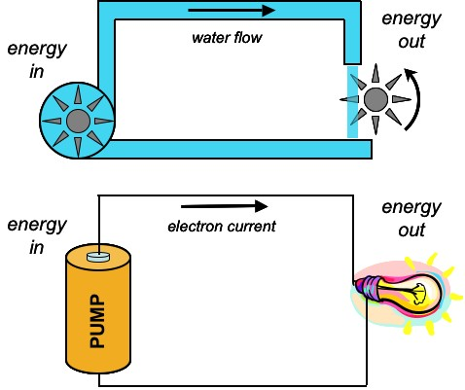 **current = charge passing a point / time**

**I = Q/t**

* The **unit** of measure for current is the ________________
* The **symbol** for current is ________
* **Current** is the ___________________ (or amount of electrons) that pass through a wire per _____________________ (second)

**Ammeter**

* measures the amount of current flowing past a _________________________ in a circuit
* it is connected in ______________

The **ammeter** shows the current at this point

**Video: Electricity – Current**

1. Ben Franklin thought the charge on clouds was ______________. We now know it is _____________________.
2. The flow of charge is called __________________.
3. In a battery, electrons flow from the ________________ to the ________________.
4. A light bulb turns electrical energy into ______________ and ______________ energy.
5. How is alternating current different from direct current?
6. A solar cell converts _______________ into electrical energy. A thermocouple converts __________________ into electrical energy.
7. A wire hold electrons much like a pipe that is full of __________________.
8. Current (I) = __________________. Is defined as the amount of _________________ passing a point in a given ___________________. One coulomb of charge is equal to __________________________ electrons.
9. 1 ampere = 1 coulomb per ______________. Therefore 5 C past a point in 2 s gives a current of ________________.