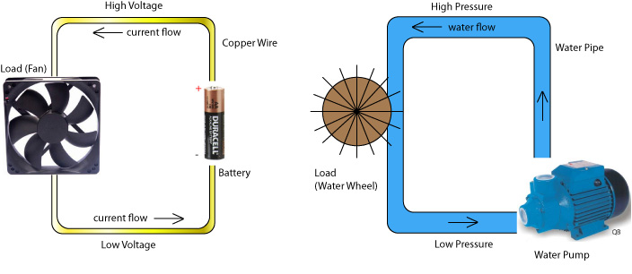**Potential Difference (Voltage):**

* Electrons flow through a conductor when there is a _____________ of electrons at one pole of the energy source and a ________ at the other pole. The electrical ________________ of the two poles is ___________________
* Although the electrons have the ***potential*** for doing work, they cannot do so until the cell is connected to a ___________ and the circuit is _________________.
* ***Potential Difference (V)*** – the _________ between two points in a circuit.
* It is measured with a ________­­­­­­­___________________.
* The **units** are ______________
* The **_____________________** **increases** the energy
* The _____________________ **decreases** the energy

**Voltmeter**

* measures the _________ in electrical energy or “pressure” between two points in a circuit
* always connected in ___________________ because it must read the ___________________________________________________ in the circuit

The **voltmeter** shows the drop in energy

from this point

to this point

**Video: Electricity – Potential Difference**

1. If the same amount of current makes one light bulb brighter than another light bulb, which electrons are giving up more energy?

***Answer:*** The ones flowing through the: bright / dim bulb (circle correct word)

1. Connecting wires are chosen to allow electrons to pass with little loss of __________________ _____________________
2. Potential difference is measured in _______________ and the symbol is _______.
3. Good conductors have ___________ potential difference.