**VIRTUAL LAB : Measuring Voltage**

**Problem:** How does the potential difference across the **source** compare to the potential difference across the **loads**?

Hypothesis:If____________________________________________________________________________________________then_________________________________________________________________________________________

**Procedure:**

1. You will again be using [PhET to create simple circuits](https://phet.colorado.edu/sims/html/circuit-construction-kit-dc/latest/circuit-construction-kit-dc_en.html) (ctrl click to launch, when it opens, click the Lab Button to begin) and test the potential difference across different areas within the circuit. Create and draw a circuit like the one below (Circuit A)

**Circuit A**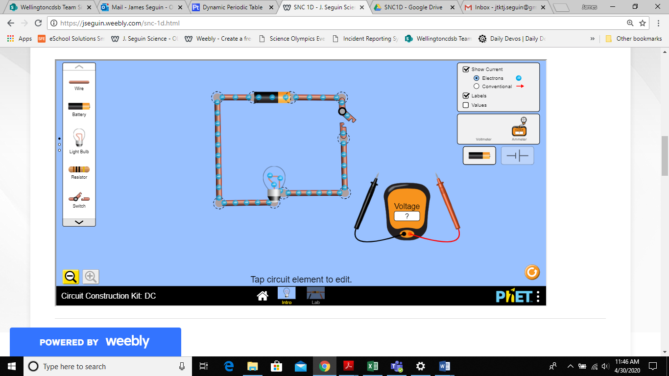

# Circuit A - diagram

1. Using the voltmeter, measure the voltage across the battery and record it below.

**Circuit A**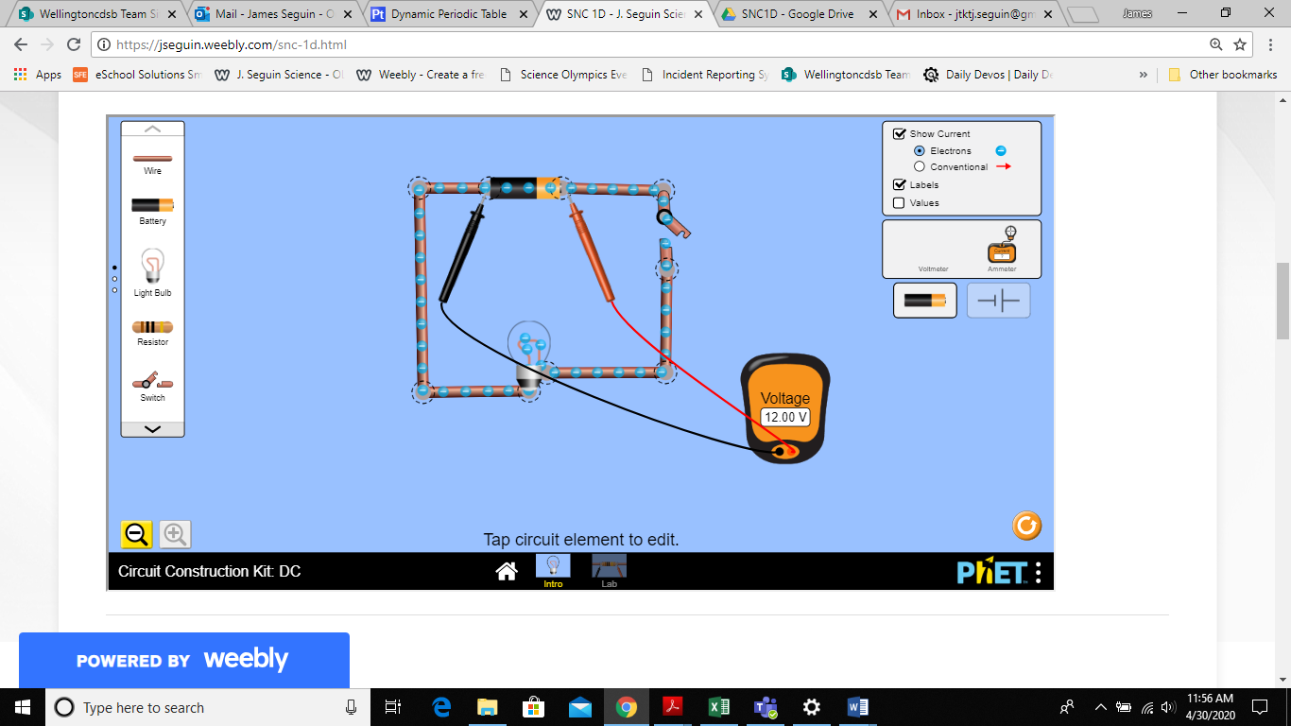

|  |  |
| --- | --- |
| **Potential Difference of Battery (V)** |  |

1. Close the switch. Predict the voltage across the light bulb with the current flowing. Record in the table below. Use the voltmeter and measure the voltage across the light bulb and record below. Repeat this step with the switch open.

|  |  |  |
| --- | --- | --- |
| **Voltage Across Light Bulb (V)** | **Prediction** | **Actual** |
| Switch closed |  |  |
| Switch open |  |  |

1. Add a second light bulb and an ammeter in series with the first bulb (Circuit B). Make predictions about the voltage at various places around the circuit as indicated by the dashed lines on the circuit diagram below. Record your predictions. Close the switch and measure the voltages at the various points and record in the table below.

**Voltage**

# Circuit B

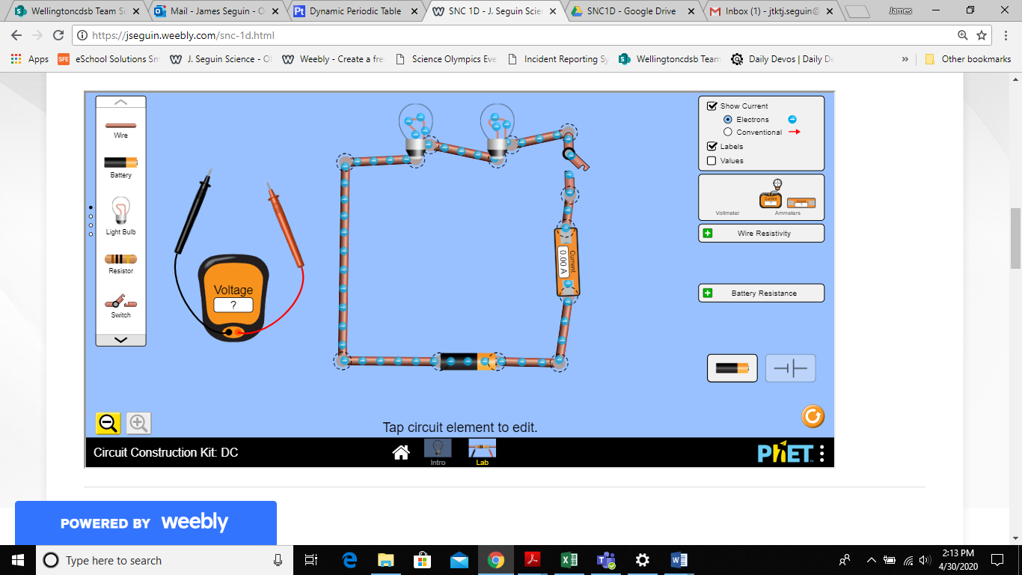

# Circuit B



|  |  |  |
| --- | --- | --- |
| **V** | **Prediction** | **Actual** |
| V1 |  |  |
| V2 |  |  |
| V3 |  |  |
| V4 |  |  |
| V5 |  |  |
| V6 |  |  |

**Discussion:**

1. What happens to the potential difference across a bulb when you open the switch?

2. How does the energy that the battery gives to the electrons (voltage of the battery) compare to the energy that the electrons give to the loads (voltage across the light bulbs)? Explain how your observations led you to your answer.

3. If no current flows through a load, how much energy does the load receive? Explain how your observations support your answer.

**Complete and share with me through your Google Drive.**