***Determining Empirical Formula-Virtual Lab***

**Background Information:**

A great deal of chemical knowledge has been amassed by using simple combustion experiments conducted with crucibles, burners, and balances. In this experiment, you are using this technique to experimentally determine the empirical formula of magnesium oxide. This lab illustrates (1) the law of conservation of mass and (2) the law of constant composition.

1. The total mass of the products of a reaction must equal the total mass of the reactants.
2. Any portion of a compound will have the same ratio of masses as the elements in the compound.

Molecular composition can be expressed three ways:

1. In terms of the number of each type of atom per molecule or per formula unit (the formula).
2. In terms of the mass of each element per mole of compound.
3. In terms of the mass of each element present to the total mass of the compound (mass percent).

The empirical formula of a compound gives the lowest whole-number ratio of the constituent atoms that is consistent with the mass ratios measured by experiment. In this lab, magnesium metal (an element) is oxidized by oxygen gas to magnesium oxide (a compound). Magnesium reacts vigorously when heated in the presence of air. The Mg -O2 reaction is energetic enough to allow some Mg to react with gaseous N2. Although there is a higher percentage of N2 gas in the atmosphere than O2, O2 is more reactive and the magnesium oxide forms in a greater amount than the nitride. The small amount of nitride that forms can be removed with the addition of water, which converts the nitride to magnesium hydroxide and ammonia gas. Heating the product again causes the loss of water and conversion of the hydroxide to the oxide.

**Based on the masses of the solid reactant (Mg) and product (MgxOy), the mass in grams and the amount in moles of Mg and O in the product can be determined. Recall that the conversion factor relating grams to moles is molar mass.**

The empirical formula of magnesium oxide, MgxOy, is written as the lowest whole-number ratio between the moles of Mg used and moles of O consumed. This is found by determining the moles of Mg and O in the product; divide each value by the smaller number; and, multiply the resulting values by small whole numbers until you get whole number values.

**Materials**

* Safety goggles
* Magnesium metal, Mg
* Balance (to 0.01g)
* Ring stand
* Bunsen burner
* Ring support/ clay triangle
* Crucible/ lid
* Tongs
* Clay tile

**Caution:**  
Eye protection is essential.  
Open flame will be present. FIRE = BAD.  
Do not breathe the fumes generated.  
Once any burner is lit, assume ALL equipment is hot. HOT = OUCH.  
Do not touch the crucible, lid, triangle, ring, or stand during or after they have been heated.  
Never place anything hot on a balance.  
Do not look into the crucible when it is heating.

**Watch the following video to see the experiment being performed and to obtain the measured values required to complete the calculations.**

[[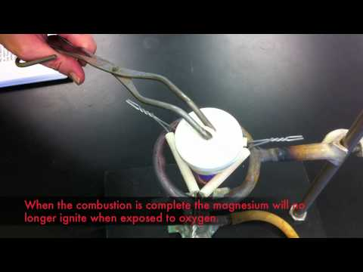](https://www.youtube.com/watch?v=OuFqtxZJRvM)](https://youtu.be/OuFqtxZJRvM)

**Procedures**

1. Fire the empty crucible and lid for about 3 minutes to remove water, oils, or other contaminants and to make sure there are no cracks. The bottom of the crucible should glow red-hot for about 20 seconds. Remove the flame and cool the crucible with lid.
2. Record the mass of crucible and lid once it has cooled.
3. Obtain about 0.5 g magnesium metal.
4. Record the mass of the magnesium, crucible and lid.
5. Place the crucible securely on the clay triangle. Set the lid ***slightly*** off-center on the crucible to allow air to enter but to prevent the magnesium oxide from escaping.
6. Place the Bunsen burner under the crucible, light it, and brush the bottom of the crucible with the flame for about 1 minute; then, place the burner under the crucible and heat strongly.
7. Heat until all the magnesium turns into gray-white powder (probably around 10 minutes).
8. Stop heating and allow the crucible, lid and contents to cool.
9. Add about 1 ml (~10 drops) of water directly to the solid powder, stir to create a paste. If you were to be able to smell the crucible, what odour do you think you would be able to detect?
10. Heat the crucible and contents, with the lid slightly ajar, ***gently*** for about 2 minutes and then strongly for about another 5 minutes.
11. Allow the crucible to cool and then record the mass of the crucible and contents.

**Complete the following section with the data from the video.**

**Results**

#### mass of empty crucible and lid _________________

#### mass of crucible, lid and Mg______________

#### mass of Mg metal

#### mass of crucible, lid and final product____________________ (why is it heavier?)

#### mass of oxide product formed (final mass – empty crucible and lid)

#### mass of O incorporated (by difference)

#### percent by mass of Mg in the oxide

#### percent by mass of O in the oxide_____________

#### ratio of moles of Mg – to – moles of O ___ :

#### empirical formula of the oxide

**Discussion/Conclusions**

* How does your experimental empirical formula compare to the formula determined using rules of nomenclature — do they match?
* What are primary sources of experimental error?
* **Show all calculations on a separate piece of paper and share the completed lab and all calculations with me through Google or sent as an attachment by email.**