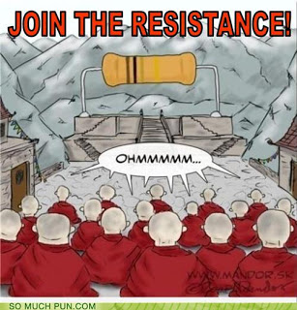**Resistance**

* Is the property of a substance that _____________________ a motion and ________________________ electrical energy to other forms of energy, like __________________________________________________
* __________________ are electrical devices used in circuits to _____________ ___________________________________. The **greater the resistance**, the more the potential ______________ (that is the **potential difference** gets __________________), as more _________________ is required to push a current through a wire.
* The scientist Georg Ohm discovered this relationship while doing experiments on the resistance of wires of various sizes. It is now known as **_______-__________________**.

Ω

* Resistance is measured in _______________. The symbol is (omega)

**The resistance of a load is:**

( ) = ____________________(________)

( )



**Written in symbols:**

R = ____ usually written as

V =

http://www.electrical-design-tutor.com/images/copper2.jpg**Questions:**

* Some conductors have a very low resistance, like copper wiring in our homes. Why is this useful?
* Some conductors have high resistance, like tungsten wire in a light bulb filament. Why is this useful?

**Complete the Table:**

|  |  |  |  |
| --- | --- | --- | --- |
| **Variable Name** | **Formula** | **Unit (& symbol)** | **Symbol** |
| Current |  |  |  |
|  |  |  | V |
|  | R = V/I | Ohms (Ω) |  |

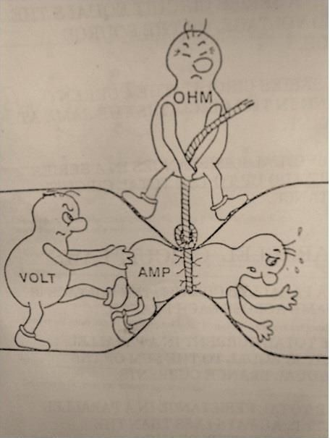**Practice Problems:**

1. A 9V battery maintains a current of 3A through a portable radio. What is the resistance of the conductor?
2. An automobile headlight has an average resistance of 24Ω. Car batteries provide a potential difference of 12V. What amount of current passes through the headlight?
3. In a portable radio, 0.5A of current are flowing through a conductor that provides 18Ω of resistance. What is the potential difference provided by the battery?
4. A clothes dryer uses a 220V power source. The coils of the heater provide an average resistance of 12Ω. What amount of current is flowing through the heating coils?
5. An electric motor has an operating resistance of 25Ω when a 4.8A current is flowing through it. What is the potential difference of the outlet the motor is plugged into?
6. A 55W light bulb will allow 0.5A to flow through it. If the outlet provides a potential difference of 110V, how much resistance is provided by the bulb?
7. Only 2.5 X 10-3 A of current pass through a portable CD player. If the CD player is operated by a 9V battery, what is the resistance in the circuit?
8. What is the resistance of a 1100W hair dryer plugged into a 110V outlet with a 10A current flowing through it?

**Factors Affecting Resistance of a Wire (p.564 in your textbook)**

|  |  |  |  |
| --- | --- | --- | --- |
| **Factor** | **Effect** | |  |
| LENGTH |  | |  |
| CROSS SECTIONAL AREA |  | |  |
| TEMPERATURE |  | |  |
| TYPE OF MATERIAL |  | |  |
|  | | |  | |
|  | | |  | |
|  | | |  | |
|  | | |  | |
|  | | |  | |
|  | | |  | |
|  | | |  | |
|  | | |  | |
|  | | |  | |
|  | | |  | |
|  | | |  | |
|  | | |  | |
|  | | |  | |
|  | | |  | |
|  | | |  | |

**Practice Problems Answers:**

***Answers***: ***1***. 3Ω; ***2.*** 0.5A; ***3***. 9V; ***7***. 3600Ω; ***8.*** 11Ω

Questions 4, 5, 6 are on the Check Your Understanding Quiz