LAB: Resistance and Ohm’s Law

Purpose: To determine the relationship between the current through a resistor and the potential drop across it.

Theory: Define:
Potential Difference:

Current:

Resistance:
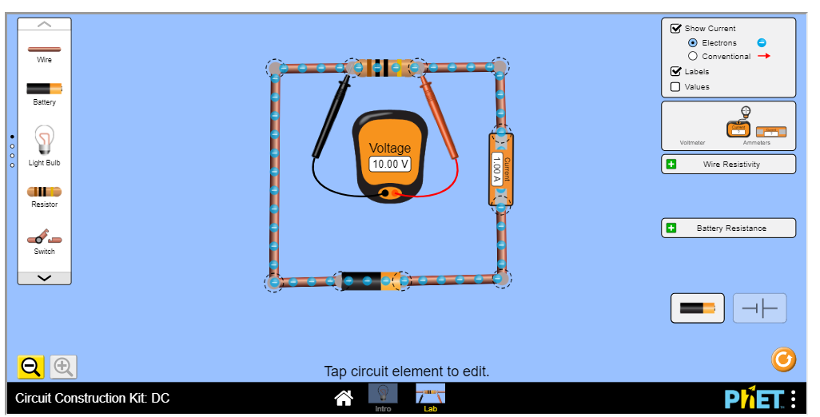
Materials:
    - Variable power supply (we can alter the battery voltage in the simulator)
    - Voltmeter
    - Ammeter
    - Resistor (the resistance of a resistor can be changed in the simulator)
    - Connecting wires

Procedure:
- Using the PhET simulator (I used the Lab option), construct the circuit as shown.
- Click on the resistor and set it to 10Ω.
- Click on the battery and adjust its voltage so you get a current of 0.10 A running through the circuit. Record the potential difference across the resistor from the voltmeter.
- Click the battery and adjust the voltage so that the current increases to 0.20 A. Record the potential difference across the resistor.
- Repeat increasing the battery voltage so that the current becomes 0.30A, then 0.40A, then 0.50A. Record the potential difference across the resistor each time.
- Click on the resistor and change it to whatever you want. Repeat steps 3-5 for the new resistor.

Observations:

Resistor #1 Resistor #2
Resistance  R (10Ω) | Current  I (A) | Potential Difference V (V) | V/I
 | 0 | 0
 | 0.10
 | 0.20
 | 0.30
 | 0.40
 | 0.50

Resistance  R ( ) | Current  I (A) | Potential Difference V (V) | V/I
Record the | 0 | 0
resistance of | 0.10
your new | 0.20
resistor | 0.30
 | 0.40
 | 0.50
Calculations:
- Calculate the ratio V/I for each pair of values. Record them in your table.
- Create a GRAPH, either by hand on paper or using a spreadsheet. Plot the potential difference V (y-axis) against the current I (x-axis), for both resistors.
- Draw a line of best fit for each resistor.

BONUS: Calculate the slope for each line. What do you notice about the slope of the graph and resistance of the resistor?

Discussion:
- Describe the shape of the V-I graph. What type of mathematical relationship exists between potential difference-V and current-I for a resistor?

- Compare the values for R, V/I, and the slope of each line. What do you notice?

Conclusion:
State Ohm’s Law

Did you verify Ohm’s Law in your lab? Explain.

Complete the lab and questions then share with me through Google Drive or send as an email attachment

