Acid/Base Basics
How does one define acids and bases? In chemistry, acids and bases have been defined differently by three sets of theories. One is the Arrhenius definition, which revolves around the idea that acids are substances that ionize (break off) in an aqueous solution to produce hydrogen (H⁺) ions while bases produce hydroxide (OH⁻) ions in solution. Acids and bases can be defined by their physical and chemical observations.

Introduction
Acids and bases are common solutions that exist everywhere. Almost every liquid that we encounter in our daily lives consists of acidic and basic properties, with the exception of water. They have completely different properties and are able to neutralize to form H₂O, which will be discussed later in a subsection. The table below compares the different properties between them:
Table 1.
ACIDS | BASES
produce a piercing pain in a wound. | give a slippery feel.
taste sour. | taste bitter.
are colorless when placed in phenolphthalein (an indicator). | are pink when placed in phenolphthalein (an indicator).
are red on blue litmus paper (a pH indicator). | are blue on red litmus paper (a pH indicator).
have a pH<7. | have a pH>7.
produce hydrogen gas when reacted with metals.
produce carbon dioxide when reacted with carbonates.
Common examples: Lemons, oranges, vinegar, urine, sulfuric acid, hydrochloric acid | Common Examples: Soap, toothpaste, bleach, cleaning agents, limewater, ammonia water, sodium hydroxide.

The Arrhenius Definition
In 1884, the Swedish chemist Svante Arrhenius proposed two specific classifications of compounds, termed acids and bases. When dissolved in an aqueous solution, certain ions were released into the solution.

Arrhenius Acids
An Arrhenius acid is a compound that increases the concentration of H⁺ ions that are present when added to water. These H⁺ ions form the hydronium ion (H₃O⁺) when they combine with water molecules. This process is represented in a chemical equation by adding H₂O to the reactants side.
HCl(aq)→H+(aq)+Cl−(aq)
In this reaction, hydrochloric acid (HCl) dissociates into hydrogen (H⁺) and chlorine (Cl⁻) ions when dissolved in water, thereby releasing H⁺ ions into solution. Formation of the hydronium ion equation:
HCl(aq)+H2O(l)→H3O+(aq)+Cl−(aq)

Incomplete Ionization (Weak Acids)
Strong acids are molecular compounds that essentially ionize to completion in aqueous solution, disassociating into H⁺ ions and the additional anion; there are very few common strong acids. All other acids are "weak acids" that incompletely ionized in aqueous solution.
Strong Acids | HCl, HNO₃, H₂SO₄, HBr, HI, HClO₄
Weak Acids | All other acids, such as HCN, HF, H₂S, HCOOH

Arrhenius Bases
An Arrhenius base is a compound that increases the concentration of OH⁻ ions that are present when added to water. The dissociation is represented by the following equation:
NaOH(aq)→Na+(aq)+OH−(aq)
In this reaction, sodium hydroxide (NaOH) disassociates into sodium (Na⁺) and hydroxide (OH⁻) ions when dissolved in water, thereby releasing OH⁻ ions into solution.
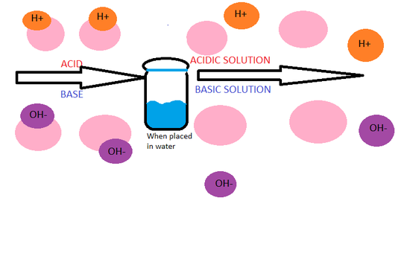
Figure 1. Arrhenius acids dissociate to form aqueous H⁺ ions and Arrhenius bases dissociate to form aqueous OH⁻ ions.
NOTE: The stronger the acid and base, the more dissociation will occur.

Incomplete Ionization (Weak Bases)
Like acids, strong and weak bases are classified by the extent of their ionization. Strong bases disassociate almost or entirely to completion in aqueous solution. Similar to strong acids, there are very few common strong bases. Weak bases are molecular compounds where the ionization is not complete.
Table 2. The strong and weak acids and bases.
STRONG BASES | The hydroxides of the Group I and Group II metals such as LiOH, NaOH, KOH, RbOH, CsOH
WEAK BASES | All other bases, such as NH₃, CH₃NH₂, C₅H₅N

pH Scale
Since acids increase the amount of H⁺ ions present and bases increase the amount of OH⁻ ions, under the pH scale, the strength of acidity and basicity can be measured by its concentration of H⁺ ions. This scale is shown by the following formula:
pH = -log[H⁺]
with [H⁺] being the concentration of H⁺ ions.
The pH scale is often measured on a 1 to 14 range. Something with a pH less than 7 indicates acidic properties and greater than 7 indicates basic properties. A pH at exactly 7 is neutral. The higher the [H⁺], the lower the pH.
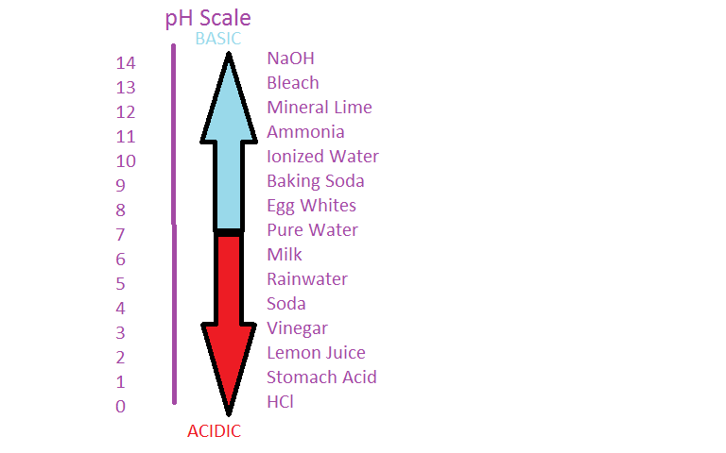
Figure 4. The pH scale shows that substances with a pH greater than 7 are basic and a pH less than 7 are acidic.

Neutralization
A special property of acids and bases is their ability to neutralize the other's properties. In an acid-base (or neutralization) reaction, the H⁺ ions from the acid and the OH⁻ ions from the base react to create water (H₂O). Another product of a neutralization reaction is an ionic compound called a salt. Therefore, the general form of an acid-base reaction is:
The following are examples of neutralization reactions:
1.
2.

