Charles's Law
Another significant advance in the study of gases came in the early 1800's in France. Hot air balloons were extremely popular at that time and scientists were eager to improve the performance of their balloons. Two prominent french scientists, Jacques Charles and Joseph-Louis Gay-Lussac, made detailed measurements on how the volume of a gas was affected by the temperature of the gas. Given the interest in hot air balloons at that time, it is easy to understand why these men should be interested in the temperature-volume relationship for a gas.
Just as Robert Boyle made efforts to keep all properties of the gas constant except for the pressure and volume, so Jacques Charles took care to keep all properties of the gas constant except for temperature and volume. A quantity of gas was trapped in a glass tube that was sealed at one end. This tube was immersed in a water bath; by changing the temperature of the water Charles was able to change the temperature of the gas.
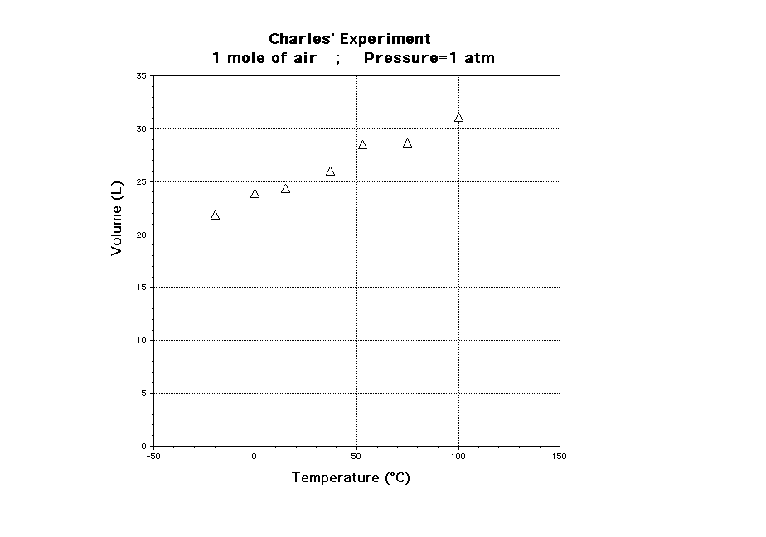
Intuitively, it is expected that the volume of the gas will increase as the temperature increases. What type of relationship is this? A plot of V vs T can be used to test this.
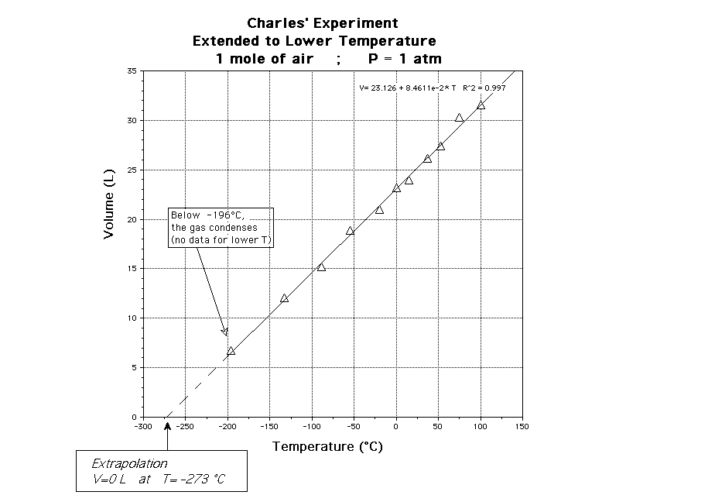
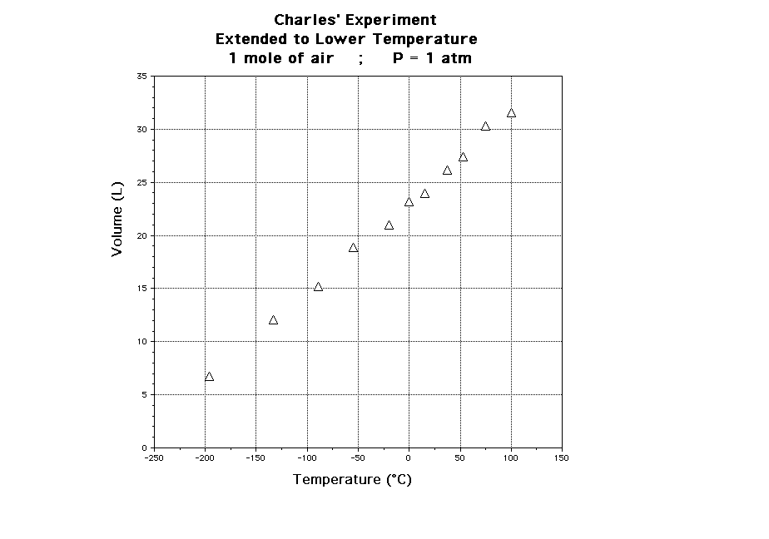
If a decrease in temperature results in a decrease in volume, what happens if the temperature is lowered to a point where the volume drops to zero?
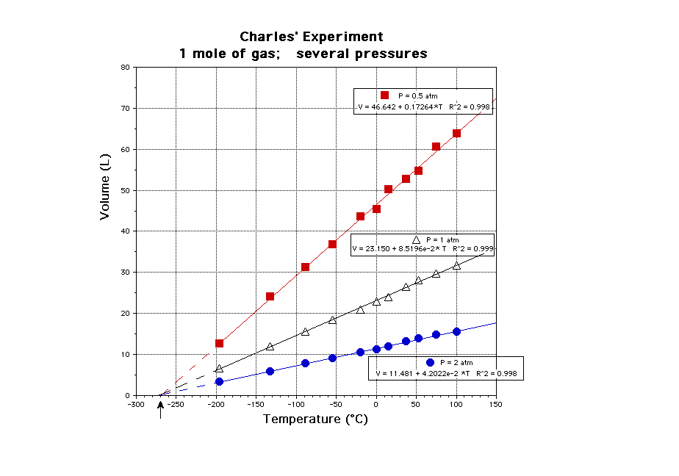
A negative volume is obviously impossible, so the temperature at which the volume drops to zero must, in some sense, be the lowest temperature that can be achieved. This temperature is called absolute zero.

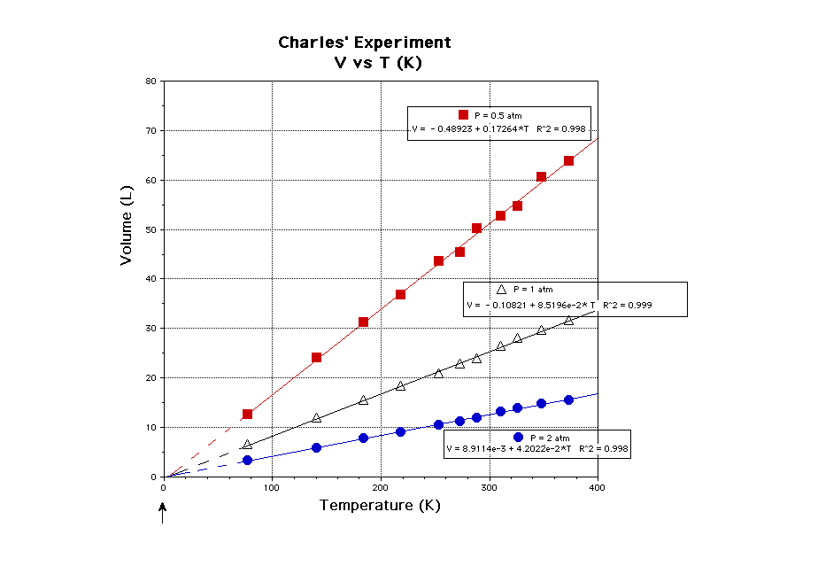

Amazingly all lines of the graph all converged on a single point. As the volume of the gas cannot be negative, we can’t go beyond this point. The graph suggests that Charles’ Law does not work at temperatures lower than this. We now know the reason for this: the lines converged on absolute zero and there are no temperatures below this temperature!
That’s worth repeating: there are no temperatures below -273.15°C. There is something fundamental in the laws of physics that means this temperature is a lower limit.
The closest we have gotten to this temperature, i.e. the current world record, was set in 1999. Researchers of the Low Temperature Laboratory of Helsinki University managed to get to 100 picokelvins (0.000 000 000 1 of a kelvin).
