Culminating Laboratory Assignment
Airbag Inflation
The goal of an airbag is to slow the passenger's forward motion as evenly as possible in a fraction of a second. There are three parts to an airbag that help to accomplish this feat:
- The bag itself is made of a thin, nylon fabric, which is folded into the steering wheel or dashboard or, more recently, the seat or door.
- The sensor is the device that tells the bag to inflate. Inflation happens when there is a collision force equal to running into a brick wall at 16 to 24 km per hour. A mechanical switch is flipped when there is a mass shift that closes an electrical contact, telling the sensors that a crash has occurred. The sensors receive information from an accelerometer built into a microchip.
- The airbag's inflation system reacts sodium azide (NaN₃) with potassium nitrate (KNO₃) to produce nitrogen gas. Hot blasts of the nitrogen inflate the airbag.
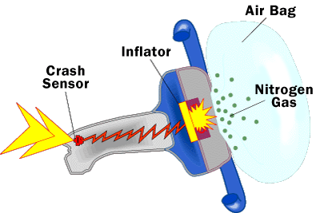
http://auto.howstuffworks.com/car-driving-safety/safety-regulatory-devices/airbag1.htm
Your Task: Create a low-tech air bag by completely filling a Ziploc sandwich bag with CO₂ gas. The reaction to be used for our air bag is acetic acid and sodium hydrogen carbonate.
Day 1: Standardization of the Acetic Acid
Titrate a known volume of acetic acid with a known concentration of sodium hydroxide. Complete at least 3 trials with consistent results and calculate the molar concentration of the acetic acid to be used for your air bag. Submit for evaluation on Day 2.[10]
Day 2: Air Bag Reaction
Using the calculated concentration from Day 1, complete stoichiometric calculations to determine the exact quantities of reactants required to completely fill (firm to the touch) the Ziploc bag. (remember, a gas is created in the reaction so room conditions are important) [5]
Measure out the appropriate amounts of reactants and perform the reaction. Show your completed reaction to your teacher for evaluation. [5]

