Name:_____________________________________________

Symbols for circuit diagrams

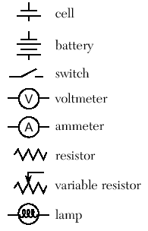**Directions:**

1. Log on to your computer
2. Go to the following website:

<http://phet.colorado.edu/en/simulation/circuit-construction-kit-dc>

Click the button that says “Play with sims…”

1. Click on the application that says Circuit Construction Kit (DC Only) It should be the first box.
2. Click “Run now.”
3. You now have the raw material to create a circuit. Take a moment to look over the site and find all the different materials. To build a circuit you will need several wires, a light bulb, a voltage source, a voltmeter, and a non – contact ammeter. Play with it to see how to grab and manipulate these tools.
4. Click the reset button.

**Types of circuits introduction**

There are many components of an *electrical circuit* or electronic circuit. Some of these components are a power supply, a resister or a switch. Above are symbols used in electronics to show the major components in a circuit.

These components can be connected in many different ways. The two simplest of these are called **series** and **parallel** and occur very frequently. Components connected in *series* are connected along a single path, so the same current flows through all of the components. Components connected in *parallel* are connected with multiple pathways so the same voltage is applied to each component.

A circuit composed solely of components connected in series is known as a **series circuit**; likewise, one connected completely in parallel is known as a **parallel circuit**.

In a series circuit, the *current* (measured in amperes) through each of the components is the same, and the *voltage* (measured in volts) across the components is the sum of the voltages across each component. In a parallel circuit, the voltage (V) across each of the components is the same, and the total current (amps) is the sum of the currents through each component.

As an example, consider a very simple circuit consisting of four light bulbs and one 6 V battery. If a wire joins the battery to one bulb, to the next bulb, to the next bulb, to the next bulb, then back to the battery, in one continuous loop, the bulbs are said to be in series. If each bulb is wired to the battery in a separate loop, the bulbs are said to be in parallel. If the four light bulbs are connected in series, there is same current through all of them, and the voltage drop is 1.5 V across each bulb, which may not be sufficient to make them glow. If the light bulbs are connected in parallel, the currents through the light bulbs combine to form the current in the battery, while the voltage drop is 6.0 V across each bulb and they all glow.

In a series circuit, every device must function for the circuit to be complete. One bulb burning out in a series circuit breaks the circuit. In parallel circuits, each light has its own circuit, so all but one light could be burned out, and the last one will still function.

**Series Circuits**

1. Build a simple series circuit that consists of 6 pieces of wire, 1 light bulb, and 1 battery (voltage source). In order to complete the circuit, the red circles at the end of each must overlap. Please note that the light bulb also has TWO circles. Your circuit is complete and working when the light comes on and the blue dots begin moving.
   1. Draw a picture of your circuit here.
   2. What do you think that the moving blue dots represent?
2. [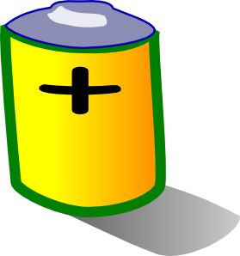](javascript:edit(8591))Use the tools at the side to get a voltmeter and a Non-contact ammeter. Put the voltmeter near the battery and place the red probe at one end and the black probe at the other.
   1. What is the voltage? __________
   2. Now switch the ends of the battery that the red and black probes touch the battery.
   3. What is the new voltage? _____________________
   4. In electronics, many things are color coded, meaning the color represents a specific condition of the wire being connected. Since voltage is a measurement of the power (driving force) of the electrons, in which voltage reading makes sense?

Electrons collect on the negative terminal of the battery. If you connect a wire between the negative and positive terminals, the electrons will flow from the negative to the positive terminal as fast as they can (and wear out the battery very quickly -- this also tends to be dangerous, especially with large batteries, so it is not something you want to be doing). Normally, you connect some type of **load** to the battery using the wire. The load might be something like a [light bulb](http://www.howstuffworks.com/light-bulb.htm), a [motor](http://www.howstuffworks.com/motor.htm) or an electronic circuit like a [radio](http://www.howstuffworks.com/radio.htm).

* 1. From what you have already read and observed, does the red color represent the Positive side or the negative side? Explain your answer.

1. Place the ammeter crosshairs over the moving blue dots. What is the reading? _______
   1. What does this tell us about the circuit?

Amperage is the amount of electrical current flowing through a circuit. It is measured in amperes, abbreviated amps. In practical terms, the ampere is a measure of the amount of [electric charge](http://en.wikipedia.org/wiki/Electric_charge) passing a point per unit time. Around 6.241 × 1018 [electrons](http://en.wikipedia.org/wiki/Electron), or one [coulomb](http://en.wikipedia.org/wiki/Coulomb), passing a given point each second constitutes one ampere.

1. Use the right click button to play with the resistance and voltage of the battery. Make observations on how changing each of these two settings in the battery affects the readings on the voltmeter and ammeter. Record your observations below. Be sure to record the changes you made and then the effects.
2. Click the advanced tab and alter the resistivity of the wire. Record your observations.

Click the reset button to begin working on a parallel circuit.

**Parallel Circuits**

1. Parallel circuits provide more than one path for electrons to move. Sketch a parallel circuit that includes 10 wires, 2 light bulbs and 1 voltage source.
2. Create the above parallel circuit using the simulator tool. The blue dots will be moving and both lights will be on once the circuit is complete.
3. Use the voltmeter and non-contact ammeter to measure electron flow and push.
   1. Voltage:_______ Ammeter:______
   2. How does this compare with your observations in the series circuit? Is this surprising? WHY or WHY NOT?
   3. Alter resistance of both resistors and voltage and record your observations below.
   4. Now right click on one of the wires connected to a light bulb. Remove the wire and record your observations.
   5. Does this affect the voltage, amperes, or visually change the appearance of the light bulb?
   6. Replace the wire. Now remove one of the wires touching the voltage source. What happened?

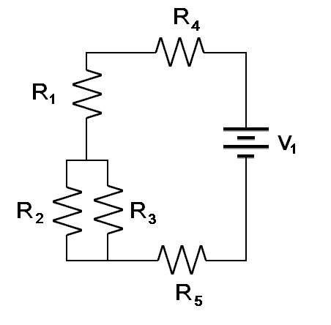Click the reset button.

**Complex Circuits**

When you combine together series circuits and parallel circuits, you create some pathways that allow the electrons to be able to travel in more than one wire.

1. Create the circuit as shown to the right and change the voltage of the battery to 30 V. Initially set the resistance to 10 ohms (the greek leter capital omega (Ω) is the symbol used to label ohms). Now using your voltmeter and ammeter, measure the voltage and amperage of each resistor. Then using Ohm’s law, (voltage (V) = amperage (I) times resistance (R) , calculate the resistance for each resistor or pair of resistors in each circuit.
2. 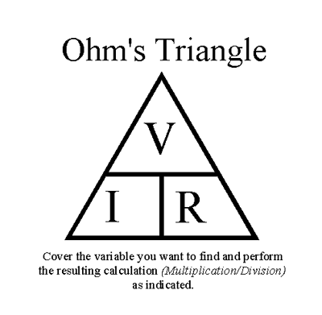After you fill I the tables below, answer the following questions:
   1. What effect does it make to have R2 & R3 in parallel and not series?
   2. How could you replace R2 and R3 with a single resistor so that the Voltage, amperage and resistance at R1 does not change?

Voltage in battery ________________________

|  |  |  |  |  |
| --- | --- | --- | --- | --- |
| Resistor | Voltage  (V) | Measured Resistance  (Ω) | Amperage  (A) | Calculated resistance  R=V/I |
| R1 |  |  |  |  |
| R2 |  |  |  |  |
| R3 |  |  |  |  |
| R4 |  |  |  |  |
| R5 |  |  |  |  |
| Before the parallel circuit |  |  |  |  |
| After the parallel circuit |  |  |  |  |
| Total of R1,Parallel circuit, R4 & R5 |  |  |  |  |

Now change each of the resistors so they each have a different value and repeat the measurements and calculations.

|  |  |  |  |  |
| --- | --- | --- | --- | --- |
| Resistor | Voltage  (V) | Measured Resistance  (Ω) | Amperage  (A) | Calculated resistance  R=V/I |
| R1 |  |  |  |  |
| R2 |  |  |  |  |
| R3 |  |  |  |  |
| R4 |  |  |  |  |
| R5 |  |  |  |  |
| Before the parallel circuit |  |  |  |  |
| After the parallel circuit |  |  |  |  |
| Total of R1,Parallel circuit, R4 & R5 |  |  |  |  |