SNC1D Physics Unit Review (Current Electricity)
You should be able to drawing circuit diagrams and symbols for the following: light bulb, resistor, ammeter, voltmeter, switch, conducting wire, power source, fuse
You should be able to identify an electric circuit as: closed, complete, open, controlled, fused, short
You should be able to perform calculations involving: Current, Potential Difference, Resistance, Ohm’s Law, Power and Efficiency
Property | Symbol | Description | Unit | Unit Symbol
Charge | Q | A measure of the number of electrons | Coulombs | C
Time | t | A measure of the time for something to occur | seconds | s
Current | I | The flow rate of electrons within a circuit | Ampere | A
Potential Difference (Voltage) | V | The change in energy of the electrons between any two points in a circuit | Volt | V
Resistance | R | The property of a substance that hinders a motion and converts electrical energy to other forms of energy | Ohm | Ω
Energy | E | The ability to do work | Joule | J
Power | P | The rate at which electrons spend(convert) their energy | Watt | W
You should be able to identify the quantities covered in the unit:

You can use the following formulas (you must complete):
Current = V/R

Potential Difference = IR

Resistance = V/I

Power = E/t

Power = VI

% Efficiency = (useful energy)/(total energy) x 100

- It takes 336000J of energy to melt 1kG of ice. How long would it take to melt this 1kG if you were using a heater with a power of 5000W? 67.2s = 1.12minutes
- How much energy does a 1200W dishwasher use when it runs for 20 minutes? 1440000J = 1440kJ
- A current of 1.5A flows through a flat pannel TV when it is plugged into a 120V wall socket. What is the resistance of the TV? 80Ω
- Calculate the current through a waffle maker that has a power rating of 0.750kW and is plugged into a 120V socket. 6.25A
- A 2500W dryer gives off 1333kJ of usable energy in 10 minutes. What is the % efficiency of this dryer? 88.9%
- Draw a diagram of a circuit that has 3 light bulbs in series, two cells, a switch, an ammeter and a voltmeter that is measuring the voltage across one of the bulbs.

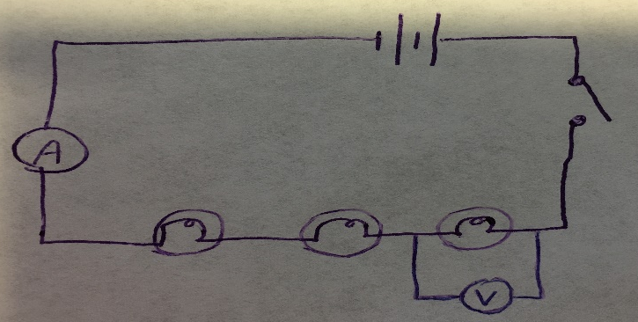
- Draw a diagram of a circuit that has 3 light bulbs, two cells and a switch, but if the switch is opened, only one of the light bulbs goes off.

