SCH 3U Final Exam Review

Unit 1: Matter and Chemical Bonding
1. ANS:

Element name | Element  symbol | Atomic  number | Group  number | Family  name | Period  number | Metal or  nonmetal
fluorine | F | 9 | 17 | halogens | 2 | nonmetal
barium | Ba | 56 | 2 | alkali earth metals | 6 | metal
argon | Ar | 18 | 18 | noble gas | 3 | nonmetal

2. ANs:
2

3. ANS:
halogens

4. ANS:
Electronegativity is a measure of an element's ability to attract electrons.

5. ANS:
Ionization energy is the energy required to remove an electron from an atom. Electron affinity is the energy released when an atom accepts an electron.

6. ANS:
Ionization energy increases because atomic radius decreases. This happens because the nuclear charge increases, but the number of energy levels does not. Therefore, the nucleus has a stronger hold on the electrons as the nuclear charge increases.

7. ANS:
helium

8. ANS:
higher

9. ANS:
3, 4, 6, and 8

10. ANS:
(a)
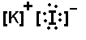
(b)
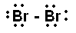
(c)

(d)
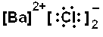

11. ANS:
Theoretically, ionic compounds consist of very large numbers of positive and negative ions attracting one another in a regular geometric three-dimensional arrangement called a crystal lattice.

12. ANS:
They may be solids, liquids, or gases at SATP (a great variation in melting and boiling points), are brittle in solid form (not flexible, malleable, ductile, or bendable), and are nonlustrous (not shiny).

13. ANS:
Substance IV is most likely to be an ionic compound because its high solution conductivity indicates that ions are present in the solution.

14. ANS:
Calcium forms an ion with a 2+ charge and chlorine forms an ion with a 1– charge. This means that the smallest unit with a zero charge would require one calcium ion and two chloride ions.
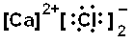

15. ANS:
Sodium forms an ion with a 1+ charge and oxygen forms an ion with a 2– charge. This means that the smallest unit with a zero charge would require two sodium ions and one oxide ion.
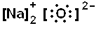

16. ANS:

ammonium ion | ammonia
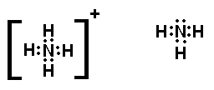

17. ANS:

carbon dioxide | carbon monoxide

18. ANS:
To obtain stable octets, two oxygen atoms will share electrons with one another. Fluorine does the same. The result is explained by the following diagrams.
19. ANS:
The following diagram shows the electron dot diagram for ammonia. The high electronegativity of nitrogen compared to hydrogen causes the electrons to spend more time with the nitrogen, thus causing a partial negative charge at the nitrogen atom and a partial positive charge at the hydrogen atoms.
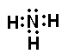

Unit 2 Part 1: Nomenclature
NaF | Sodium fluoride
CCl4 | Carbon tetrachloride
MgO | Magnesium oxide
CaSO4 | Calcium sulphate
MgS | Magnesium sulphide
CaF2 | Calcium fluoride
N2O4 | Dinitrogen tetroxide
NaBr | Sodium bromide
Li3N | Lithium nitride
Na3PO4 | Sodium phosphide
AlCl3 | Aluminum chloride
NO2 | Nitrogen dioxide
Pb(NO3)2 | Lead (II) nitrate
CO | Carbon monoxide
CuSO4 | Copper (II) sulphate

Potassium oxide | K2O
Lithium sulphide | Li2S
Sodium carbonate | Na2CO3
Nitrogen dioxide | NO2
Potassium fluoride | KF
Iron (II) chloride | FeCl2
Carbon tetrafluoride | CF4
Aluminum nitride | AlN
Silicon dioxide | SiO2
Ammonium hydroxide | NH4OH
Copper (I) nitrate | CuNO3
Diphosphorous pentoxide | P2O5
Sodium phosphide | Na3P
Aluminum sulphate | Al2(SO4)3
Calcium chloride | CaCl2

Unit 2 Part 2: Reactions
1. ANS:
H₂SO_{4(aq)} + 2NaOH_{(aq)} 2HOH_{(l)} + Na₂SO_{4(aq)}

2. ANS:
2HgO_{(s)} 2Hg_{(l)} + O_{2(g)}

3. ANS:
Cu_{(s)} + 2AgNO_{3(aq)} Cu(NO₃)_{2(aq)} + Ag_{(s)}

4. ANS:
3CaCl_{2(aq)} + 2Na₃PO_{4(aq)} Ca₃(PO₄)_{2(s)} + 6NaCl_{(aq)}

5. ANS:
CH_{4(g)} + 2O_{2(g)} CO_{2(g)} + 2H₂O_{(g)}

6. ANS:
C_{(s)} + O_{2(g)} CO_{2(g)}

7. ANS:
water and carbon dioxide

8. ANS:
2FeCl_{3(aq)} + 3Zn_{(s)} → 3ZnCl_{2(aq)} + 2Fe_{(s)}

Unit 3: Quantities in Chemical Reactions
1. ANS:
A specific compound always contains the same elements in definite proportions by mass.

2. ANS:
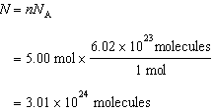

3. ANS:
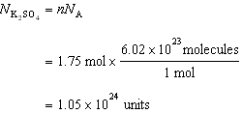
Since there are four oxygen atoms in each unit of potassium sulfate, there are 4.2 × 10²⁴ atoms of oxygen present.

4. ANS:
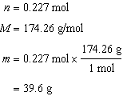
The mass of 0.227 mol of K₂SO₄ is 39.6 g.

5. ANS:
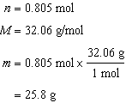
The mass of 0.805 mol of S is 25.8 g.

6. ANS:
A molecular formula shows the actual number of atoms of each element in a molecule of a compound. (C₆H₁₂O₆)
An empirical formula is the simplest formula and shows only the relative number of moles of each type of atom in a compound. (CH₂O)

7. ANS:
C₂H₅OH_{(aq)} + 3O_{2(g)} 2CO_{2(g)} + 3H₂O_{(g)}

8. ANS:
mole ratio ZnS:ZnO = 1:1

Unit 4: Solutions
1. ANS:
Sodium nitrate is an ionic solid and will dissolve more easily as temperature increases because warmer water has greater heat energy to overcome the attractive forces between the sodium and nitrate ions. Oxygen is a gas and its molecules must gain more energy to overcome the attractive forces of the water molecules and escape the solution.

2. ANS:
Water is a polar molecule because it has a slightly positive and negative end. The oxygen atom is negative because it has a greater electronegativity (a stronger ability to attract electrons) than the hydrogen atoms do. The oxygen pulls the shared electrons closer to itself, making it more negative and the hydrogen more positive.

3. ANS:
Compound | Soluble or insoluble
(a) PbI₂ | insoluble
(b) KClO₃ | soluble
(c) CaCO₃ | insoluble
(d) BaSO₄ | insoluble

4. ANS:
A saturated solution is one that cannot dissolve any more solute at a specific temperature. An unsaturated solution is one that contains less solute than it can usually hold at a given temperature. A supersaturated solution is one that contains more solute than it can usually hold at a given temperature.

5. ANS:
(a) Ni(NO₃)_{2(aq)} + Na₂SO_{3(aq)} → NiSO_{3(s)} + 2NaNO_{3(aq)}
(b) Ni²⁺_{(aq)} + 2NO₃–_{(aq)} + 2Na⁺_{(aq)} + SO₃^{2–}_{(aq)} → NiSO_{3(s)} + 2Na⁺_{(aq)} + 2 NO₃–_{(aq)}
(c) Ni²⁺_{(aq)} + SO₃^{2–}_{(aq)} → NiSO_{3(s)}

6. ANS:
Ca(OH)_{2(s)} → Ca²⁺_{(aq)} + 2OH–_{(aq)}

7. ANS:
Acids
-tastes sour
-turns blue litmus red
-reacts with active metals to produce hydrogen gas

Bases
-tastes bitter
-feels slippery
-has a pH higher than 7
-neutralizes acids

8. ANS:
An Arrhenius acid is a substance that reacts with water to form hydronium ions. An Arrhenius base is a substance that dissociates to form hydroxide ions.

9. ANS:
A Bronsted acid is a proton donor. A Bronsted base is a proton acceptor.

10. ANS:
HF_{(aq)} and F–_{(aq)} are conjugate acid-base pairs. H₃O⁺_{(aq)} and H₂O_{(l)} are conjugate acid-base pairs.

11. ANS:
H₃PO_{4(aq)} + 3KOH_{(aq)} → K₃PO_{4(aq)} + 3H₂O_{(l)}

Unit 5: Gas Laws

1. ANS:
P₂ = 3P₁
T₂ = 2T₁
V₂ = xV₁

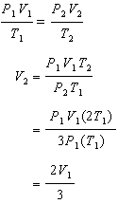
The final volume will be that of the initial volume.
2. ANS:
translational, rotational, and vibrational motions

3. ANS:
kinetic molecular theory

4. ANS:
gas, liquid, solid

5. ANS:
Gas particles are relatively far apart compared to their size. Solids have particles that are very close to each other, while liquids have small spaces between particles. To compress a substance, the particles must be brought closer together. Since gas particles are far apart, their total occupied volume can be easily changed by applying a force such as increasing the pressure or decreasing the temperature.
6. ANS:
The volume of a gas varies indirectly with the pressure acting upon the gas. As the pressure goes up the volume goes down to form a curve on the graph.

7. ANS:
Assume that the number of particles in a gas and the temperature of the gas remains constant. As the pressure increases on the gas, the particles will be forced to move in closer to one another, thereby decreasing the total volume that they occupy. As the volume decreases, there will be more collisions with the sides of the container due to the reduction of exposed surface area, but the number of particles is constant. (More particles hitting the same spot on the sides of the wall increases the pressure.)

8. ANS:
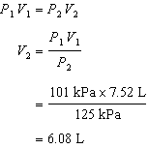

9. ANS:

P₁ | V₁ | T₁ | P₂ | V₂ | T₂
100 kPa |  | 298 K | 125 kPa | 15.5 L | 375 K

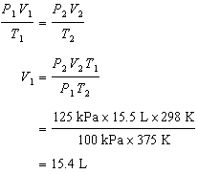

10. ANS:

P₁ | V₁ | T₁ | P₂ | V₂ | T₂
375 kPa | 475 mL | 12ºC = 285K | 99.5 kPa |  | 308 K

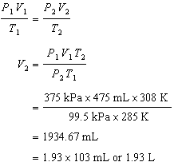

Additional Practice

1. ANS:
Ar-36: 0.34% or 34 atoms
Ar-38: 0.06% or 6 atoms
Ar-40: 99.60% or 9 960 atoms

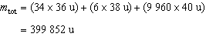

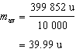
The average atomic mass of argon is 39.99 u.

2. ANS:
m_{Na} = 23.00 u × 2 atoms = 46.00 u
m_{S} = 32.10 u × 2 atoms = 64.20 u
m_{O} = 16.00 u × 3 atoms = 48.00 u
m_{total} = 158.20 u

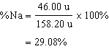

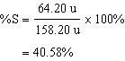

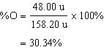
The percentage composition, by mass, of Na₂S₂O₃ is 29.08% sodium, 40.58% sulfur, and 30.34% oxygen.

3. ANS:
m_{H} = 2.20% × 100.0 g H = 2.20 g |  | M_{H} = 1.01 g/mol
m_{C} = 26.7% × 100.0 g C = 26.7 g |  | M_{C} = 12.01 g/mol
m_{O} = 71.1% × 100.0 g O = 71.1 g |  | M_{O} = 16.00 g/mol

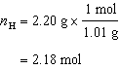

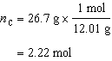

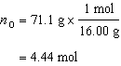

The molar ratio for H:C:O is 2.18:2.22:4.44. Dividing by 2.18 to obtain the lowest ratio, we obtain the molar ratio of H:C:O to be 1:1:2.
The empirical formula of the compound is HCO₂.

4. ANS:
m_{C} = 39.95% × 100.0 g C = 39.95 g |  | M_{C} = 12.01 g/mol
m_{H} = 6.71% × 100.0 g H = 6.71 g |  | M_{H} = 1.01 g/mol
m_{O} = 53.34% × 100.0 g O = 53.34 g |  | M_{O} = 16.00 g/mol

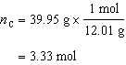

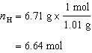

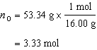

The molar ratio for C:H:O is 3.33:6.64:3.33. Dividing by 3.33 to obtain the lowest ratio, we obtain the molar ratio of 1:2:1. The empirical formula of the compound is CH₂O.

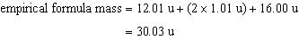

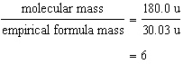
The molecular formula of the compound is C₆H₁₂O₆.

5. ANS:
balanced equation: 2KClO₃ 2KCl + 3O₂

mole ratio: | KClO₃:KCl = 1:1

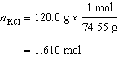

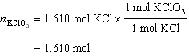

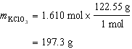
The amount of potassium chlorate required to produce 120.0 g of KCl is 197.3 g.

6. ANS:
mole ratio: | CaCl₂:AgCl = 1:2

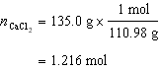

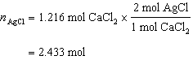
The number of moles of AgCl that will be produced is 2.433 mol.

7. ANS:
mole ratio: | Zn(NO₃)₂:Li₃PO₄ = 3:2

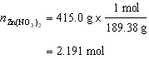

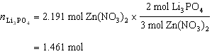

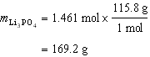
The mass of lithium phosphate required is 169.2 g.

8. ANS:
We can determine the number of moles of oxygen gas needed to react completely with 12.0 g of methane.
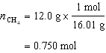

mole ratio: | CH₄:O₂ = 1:2

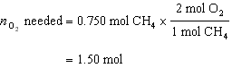

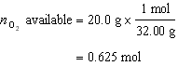
There is not enough O₂ available for 12.0 g of methane to react completely.
The oxygen gas is the limiting reagent.

9. ANS:
We can determine the number of moles of oxygen gas needed to react completely with 15.0 g of methane.
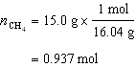

mole ratio: | CH₄:O₂ = 1:2

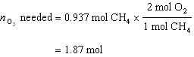

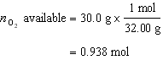
There is not enough O₂ available for 15.0 g of methane to react completely. The oxygen gas is the limiting reagent.

mole ratio: | O₂:CO₂ = 2:1

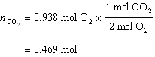

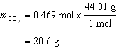
The mass of carbon dioxide produced is 20.6 g.

10. ANS:
We can determine the number of moles of chlorine needed to react completely with 15.9 g of Na.
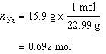

mole ratio: | Na:Cl₂ = 2:1

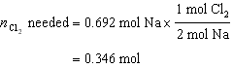

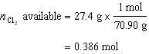
More chlorine is available than is required, therefore, chlorine is in excess. The sodium is the limiting reagent.

mole ratio: | Na:NaCl = 1:1

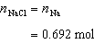

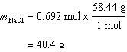
The theoretical yield of the NaCl is 40.4 g.

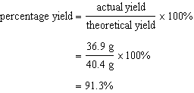
The percentage yield is 91.3%.

11. ANS:
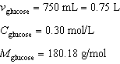

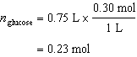

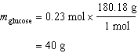
The mass of glucose needed is 40 g.

12. ANS:
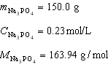

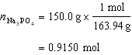

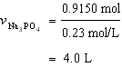
The volume of the solution will be 4.0 L.

13. ANS:
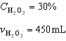

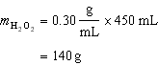
The mass of pure hydrogen peroxide 140 g.

14. ANS:
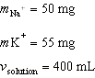

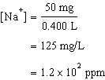

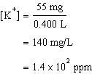
The concentration of sodium and potassium ions are 1.2 × 10² ppm and 1.4 × 10² ppm, respectively.

15. ANS:
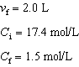

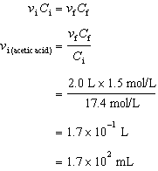
The volume of the stock acetic solution needed is 1.7 × 10² mL.

16. ANS:
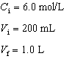

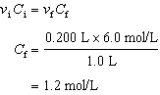
The concentration of the diluted HCl solution is 1.2 mol/L.

17. ANS:
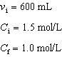

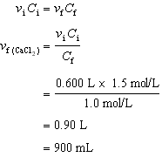

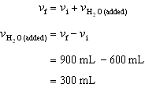
The amount of water that must be added for the dilution is 300 mL.

18. ANS:
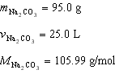

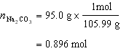

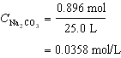
The sodium carbonate concentration is 0.0358 mol/L.

19. ANS:
H₂SO_{4(aq)} + 2NaOH_{(aq)} → Na₂SO_{4(aq)} + 2H₂O_{(l)}
10.00 mL | 8.66 mL
C | 0.00512 mol/L

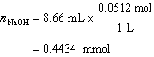

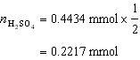

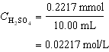
The sulfuric acid concentration in the lake is 2.22 × 10^{–2} mol/L.

20. ANS:
Mg(OH)_{2(aq)} + 2HCl_{(aq)} → MgCl_{2(aq)} + 2H₂O_{(l)}
12.0 mg | 0.01 mol/L
58.31 g/mol | v

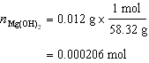

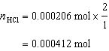

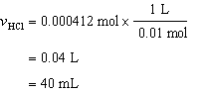
The milk of magnesia can neutralize 40 mL of stomach acid.

21. ANS:
P₁ = 125 kPa
V₁ = 7.75 L
P₂ = 101.325 kPa
V₂ = ?

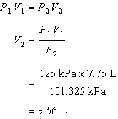
The new volume of the balloon is 9.56 L.

22. ANS:
m = 3.45 g
T = 273 K
P = 101.325 kPa
R = 8.31 kPa L/mol K
V = ?

Convert mass to moles of CO₂: 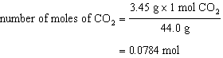

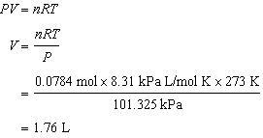
The volume occupied by the CO₂ is 1.76 L.

23. ANS:
n = 0.155 mol N₂
V = 8.95 L
T = 23ºC + 273 = 296 K
R = 8.31 kPaL/molK
P = ?

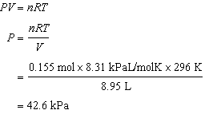
The pressure gauge would read 42.6 kPa.

24. ANS:
n = 3.25 mol
T = 25ºC + 273 = 298 K
R = 8.31 kPa L/mol K
P = 799 mm Hg
V = ?

Convert P into kPa from mm Hg: 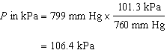

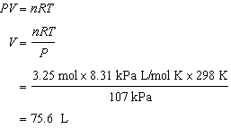
The He gas will occupy a volume of 75.6 L.

25. ANS:
V = 5.25 L
P = 105 kPa
T = 299 K
R = 8.31 kPa L/mol K
n = ?

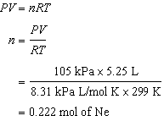

The answer would be the same if the question asked for the number of moles of nitrogen gas. The question assumes ideal gases and Avogadro's theory states that two gases at the same temperature, pressure, and volume would contain the same number of molecules. If you have the same number of molecules, you have the same number of moles; however, the masses will be different.

26. ANS:
V₁ = 775 mL
V₂ = 825 mL
T₁ = –28ºC + 273 = 245 K
T₂ = 15 K + 273 K = 288 K
P₁ = 92.5 kPa
P₂ = ?

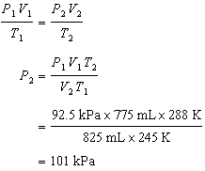
The pressure at the base of Mt. Logan is 101 kPa.

27. ANS:
V₁ = 3.25 L
V₂ = 4250 mL
T₁ = 35ºC + 273 = 308 K
T₂ = ?
P₁ = 1829 mm Hg
P₂ = 1.25 atm

Convert V₂ to L: 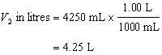

Convert P₁ to atm: 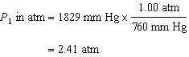

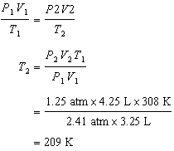

The temperature of the gas would be –64ºC.

